**MIS 273 – Lab 3**

In this lab you’ll install Windows 10 as a virtual machine (VM) and configure an organizational unit (OU) with groups and users.

**Task 1:** Watch the video entitled “Organizational Units” to learn how they are used and how to add users and groups to them. On your Windows Server 2019 Domain Controller, create a new organization unit called “Accounting”. Create 3 users within this organizational unit. Create a group “Payroll” within the organizational unit. Make the 3 users members of the Payroll group. Paste a screen-shot below of the Active Directory Users and Computers application with the Accounting OU selected so that the users and Payroll group are shown in the right-hand pane.

Paste the screen-shot here:

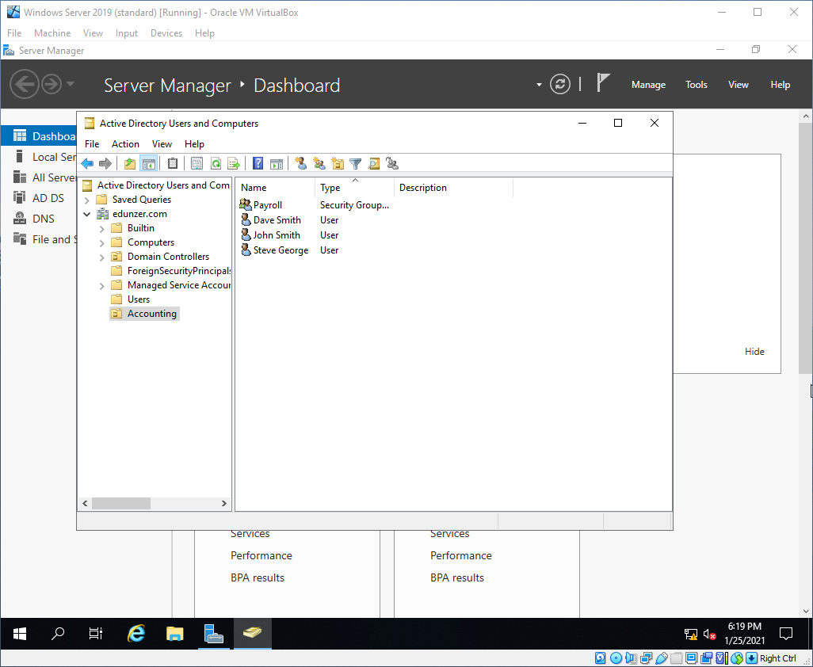

**Task 2:** Review how to set NTFS permissions from Lab 2 and chapter 3 of the textbook. On your Windows Server 2019 Domain Controller, create a folder called Payroll_Data and give the Payroll group the full control security permission on this folder. Paste a screen-shot below of the Security tab with the Payroll group selected so that its permissions are shown.

Paste the screen-shot here:

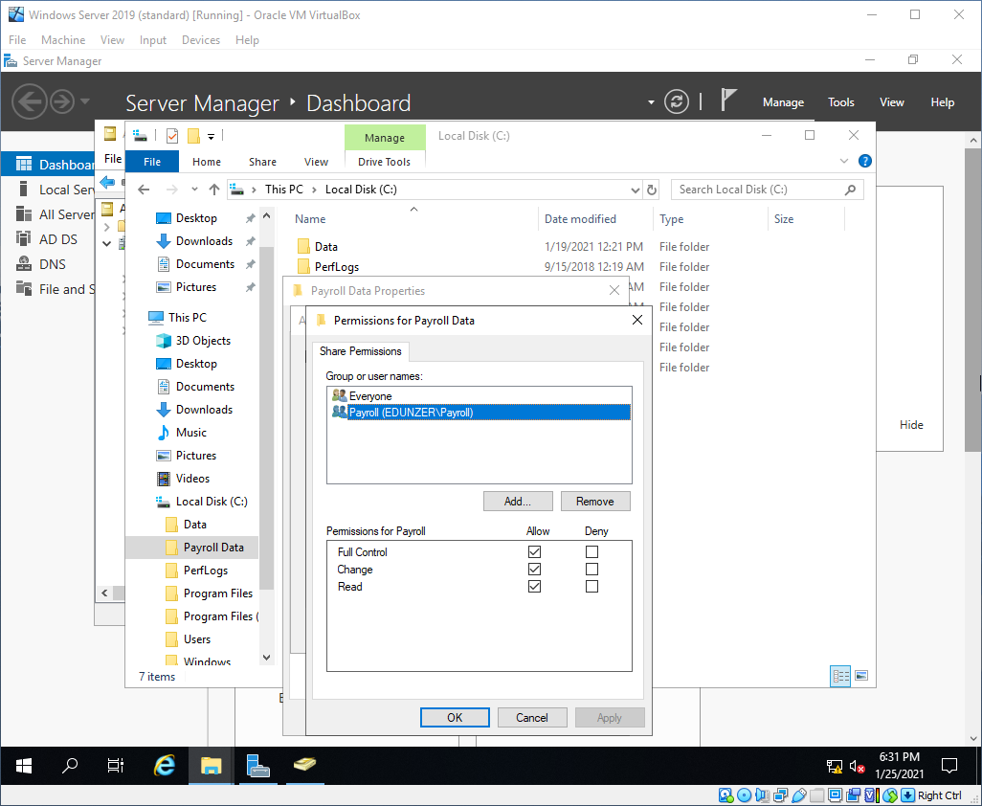

**Task 3:** As you perform this task realize that it has nothing to do with the previous two tasks. Watch the video entitled “Windows 10 Installation” and install Windows 10 as a VM. You’ll need to obtain an ISO file of it to do the install. You can use the 90 trial version of Windows 10 or use either of the two links provided in Canvas to get to an ISO. Paste a screen-shot of the installation process completed or at least near its completion below.

Paste the screen-shot here:

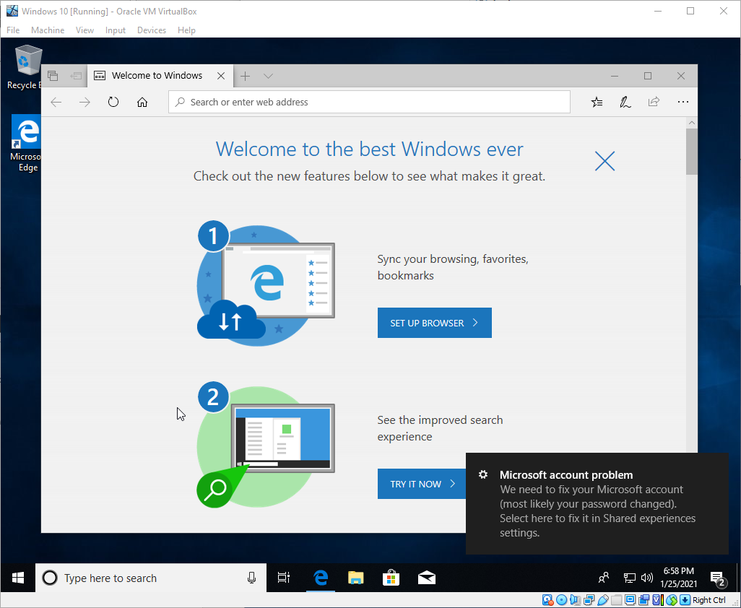

Upload this document with the screen-shots to Canvas.